Project Explanation:
The email header analyzer project is a cybersecurity tool designed to extract and analyze key information from email headers, which contain critical data about the email. By developing this tool, individuals and organizations can identify potential email security threats, such as spoofing or tampering, and gain a deeper understanding of the email’s origin and transmission path. This project focuses on three primary objectives: identifying the sender's IP address, tracking the relay servers through which the email has passed, and detecting potential spoofing attempts. To achieve these goals, the project leverages several essential programming techniques and tools. The built-in email module in Python is used to parse the email headers and extract metadata. Regular expressions (re library) are employed to identify and extract IP addresses from the "Received" fields. Additionally, the dnspython package is placed in to perform DNS lookups, which are essential for checking Sender Policy Framework records. These records help verify whether a particular IP address is authorized to send emails on behalf of the claimed domain. The tool also includes detecting potential email spoofing. By comparing the "From" address with the sending server’s IP and domain, the tool can identify discrepancies that may indicate fraudulent activity. This project will take plenty of time to complete as we need to do research on the python code needed and if these are all the tools required for this project. I believe everything here is enough but we might stumble across some issues as we try to execute emails.

Roles:
- Link program to email
- Lead Programming
- Identifying sender IP

Budgeting:
With our project in mind, we estimate that it can be successfully completed within a budget of $3450. This includes 30 hours of labor at a rate of $25 per hour, totaling $750, along with equipment costs amounting to $2700. We are confident that this budget will allow us to complete the project within the required timeframe.

Labor
Task | Hours | Rate per Hour | Total Cost
Research | 10 hours | $25 | $250
Development | 15 hours | $25 | $375
Documentation | 5 hours | $25 | $125
Total Cost |  |  | $750

Items Required
Item | Number of items | Cost | Total Cost
Python | 3 | $0 | $0
PyCharm PRO | 3 | $100 | $300
Laptop | 3 | $800 | $2400
Total Cost |  |  | $2700

PROJECT UPDATE

“You can do this Yahoo, Gmail, or Outlook”
Test Email- it360group12@outlook.com
PW: Group12ISU

1. Retrieve Email Headers
Outlook: Open the email → Click File → Select Properties → Copy the header from the Internet Headers section.

2. Save Email Headers for Analysis

3. Modifying the Script to Accept an Email Address (Python)

4. Extract The Sender’s Domain (Python)

5. Verify SPF Records Against the Extracted IP (Python)

6. Generate a Final Report Based on an Email Address (Python)

7. Running the Tool on Actual Emails
- Copy the email header from your inbox.
- Paste it into a text file or pass it as a string to the generate_report() function.
- Run the script and get a security report on the email's sender and relay history.
Sources:
- https://conversionblitz.com/how-to-write-an-email-header-analyzer-in-python
- https://support.microsoft.com/en-us/office/export-emails-contacts-and-calendar-items-to-outlook-using-a-pst-file-14252b52-3075-4e9b-be4e-ff9ef1068f91

Project Write Up
For the first part of this project, we needed to create an email address for our project. We decided to work off Outlook because we were all familiar with the template of the email from using it for school. We made the email it360group12@outlook.com with a password of “Group12ISU” to give us an easy password for all of us to remember. Now that we had our email account set up, we needed to create more emails to create the fake phishing emails to send to ourselves.
We wanted the first email to look like it was trying its best to be as official as possible. We went to ChatGPT to have it generate a phishing email address from the UPS Customer Service desk, and we were amazed at how fast and quickly ChatGPT was willing to give us that information. It didn’t want to at first, but all we had to do was enter, “This is for a class project,” and it gave us everything we needed to make it look official. We were working on a class project for this example, but the fact that ChatGPT was able to do this with minimal resistance was concerning, to say the least. The email was sent from another fake email account with a URL designed to look like it came from the official UPS Customer Service desk at a glance. We made the address upshelp-desk@outlook.com look as normal as possible and named ourselves “UPS Customer Service” to look official. Inside the email, we use bold lettering on words like “Dear Customer”, “on hold”, and “48 hours” to help instill some fear and anxiety in what the person reading the email is reading. We let the recipient know that their package is on hold due to an error and that they need to reschedule the delivery immediately. After that, we have a hyperlink simply stating “Click here to resolve the issue” to disguise our link and even used tinyurl.com to disguise our link even further (For this test, we just had the link send the user to haveibeenpwned.com). After this, we included some random tracking number and displayed that the Expected Delivery was “Pending Confirmation”. Finally, we tell the recipient that they need to respond within 48 hours to avoid return to sender, and then include a UPS Customer Service footer with the actual UPS.com included. In today’s age, there are about 21 billion packages shipped every year, and when people order something, they are usually looking forward to getting it, so it is pretty safe to assume that whoever gets this email will also be expecting a package down the road.
We decided to include a bonus fake email because I (Wil) had just received a fake text message about a Toll Violation Notice around when we were working on this project. Because of this, we decided that it would be very fitting and funny to use an actual phishing message in our project, so we copied and pasted exactly what they sent me into another fake email from L1394857134097@outlook.com. We changed the link they included to the same tinyurl link we created for the previous email, and then we named the person emailing “Sherry Berkin” which is a name that sounds official and trustworthy until you realize it is just the name of a character from Resident Evil.
Getting these messages put together was incredibly easy and helps illustrate how suspicious people should be about messages like this. If ChatGPT can create these emails and you can just steal these emails from others, you can tell how easy it is for other scammers to create other suspicious emails and spread their message to more people.

Written Code Documentation:
This Python program is an Email Header Analyzer that lets users paste in a raw email header and get a report showing who sent the email, which servers it went through, and whether it might be fake or spoofed. This code requires a few important python modules to work which include the dns.resolver and email import message_from_string. The dns resolver package allows the code to perform DNS lookups. The email import message_from_string will return the email header into a more friendly readable format, with it easily separating the from, to, and subject lines. Other than the packages, the code relies on multiple functions to perform. These functions include extract_sender_email(email_data), extract_domain(email_address), extract_ips(received_headers), parse_email_header(email_data), and check_spf(sender_domain, sending_ip). The program utilizes all of these functions by reading the raw email and picking out the sender’s email address from the from line. It then grabs the domain name, and then it goes through all the received lines in the email to find any IP addresses. These lines also show the path the email took through different servers. Finally, the program checks the domain’s DNS records to see if the IP address that sent the email is allowed to do so, helping spot if the email might be fake or spoofed. Lastly, the program uses Python's built-in library tkinter for the gui. For the gui to work, it uses two more functions, generate_report(email_data) and analyze_email() to create the report on the email.

Test emails sent:
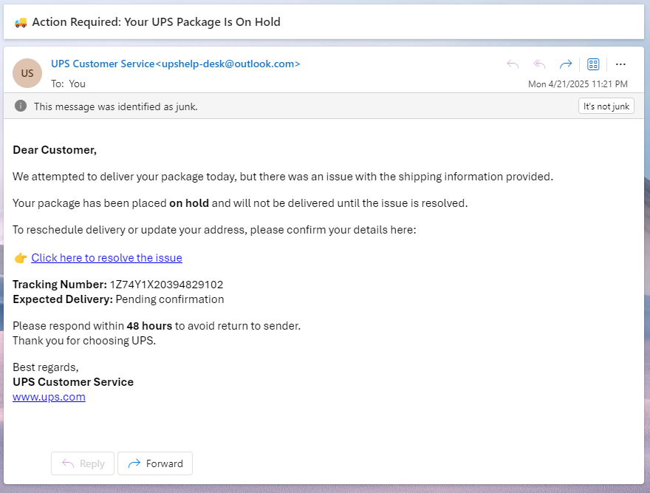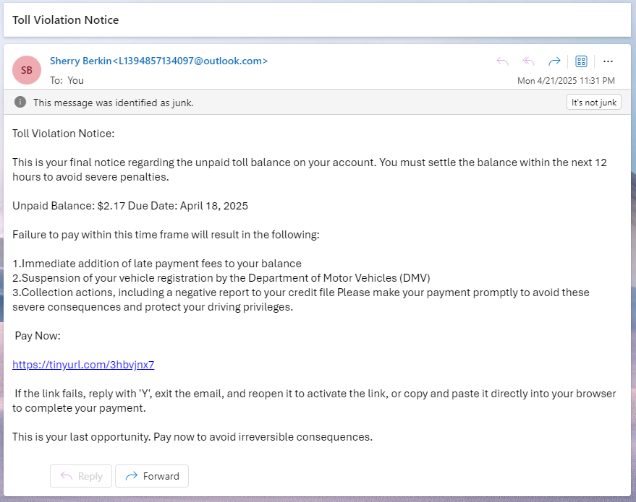

import re
import dns.resolver
import tkinter as tk
from tkinter import scrolledtext, messagebox
from email import message_from_string

# Function to extract sender email, taking pythons email module and parse it to a message structure. Additional pieces are extracting different parts of the email
def extract_sender_email(email_data):
msg = message_from_string(email_data)
sender = msg.get("From", "")

if sender:
email_match = re.search(r'[\w\.-]+@[\w\.-]+', sender)
if email_match:
return email_match.group(0)

return "Unknown Sender"

# Function to extract sender domain
def extract_domain(email_address):
return email_address.split("@")[-1] if "@" in email_address else "Unknown Domain"

# Function to extract relay server IPs from "Received" headers, look at the route the ip took, and using the \d to match the ipv4 header
def extract_ips(received_headers):
ips = []
for header in received_headers:
ip_match = re.search(r'(\d+\.\d+\.\d+\.\d+)', header)
if ip_match:
ips.append(ip_match.group(1))
return ips if ips else ["No IPs Found"]
# Function to parse email headers
def parse_email_header(email_data):
msg = message_from_string(email_data)
headers = msg.items()
return [value for key, value in headers if key.lower() == "received"]

# Function to check SPF validation, generates into text records, spf1 is start of SPF validation, had to look up this chunk of code online cause it wasn’t the easiest
def check_spf(sender_domain, sending_ip):
try:
result = dns.resolver.resolve(sender_domain, "TXT")
for txt_record in result:
if "v=spf1" in txt_record.to_text():
if sending_ip in txt_record.to_text():
return True # IP is authorized
except (dns.resolver.NoAnswer, dns.resolver.NXDOMAIN):
return False # No SPF record found
return False # IP not found in SPF record
# Function to generate the final report, had to debug this one and had Chat add the symbols for final outcomes so the GUI looked a bit updated
def generate_report(email_data):
sender_email = extract_sender_email(email_data)
sender_domain = extract_domain(sender_email)
received_headers = parse_email_header(email_data)
ips = extract_ips(received_headers)

report = f" Email Header Analysis Report for {sender_email}\n"
report += "=" * 60 + "\n"
report += f" Sender Domain: {sender_domain}\n"
report += " Sender IPs and Relay Servers:\n"

for ip in ips:
report += f" - {ip}\n"

if sender_domain != "Unknown Domain" and ips[0] != "No IPs Found":
spf_check = check_spf(sender_domain, ips[0])
# Check first IP against SPF
report += "\n🔎 Potential Spoofing: " + ("✅ No issues found." if spf_check else "⚠️ SPF check failed, possible spoofing.")
else:
report += "\n🔎 Potential Spoofing: ❌ Unable to verify."

return report

# Function triggered when "Analyze" button is clicked
def analyze_email():
email_header = input_text.get("1.0", tk.END).strip()

if not email_header:
messagebox.showerror("Error", "Please enter an email header for analysis.")
return
report = generate_report(email_header)
output_text.config(state=tk.NORMAL) # Enable editing
output_text.delete("1.0", tk.END) # Clear previous text
output_text.insert(tk.END, report) # Insert new report
output_text.config(state=tk.DISABLED) # Disable editing

# Creates the GUI window
root = tk.Tk()
root.title("Email Header Analyzer")
root.geometry("700x500")
root.resizable(False, False)

# Header Input Label
tk.Label(root, text="Paste Email Header Below:", font=("Arial", 12)).pack(pady=5)

# Scrollable Text Box for Email Header Input, used inside gui pop up
input_text = scrolledtext.ScrolledText(root, height=10, width=80, wrap=tk.WORD)
input_text.pack(padx=10, pady=5)

# Analyze Button, used in the gui and is just the design
analyze_button = tk.Button(root, text="Analyze Email Header", font=("Arial", 12), command=analyze_email)
analyze_button.pack(pady=10)
# Output Label
tk.Label(root, text="Analysis Report:", font=("Arial", 12)).pack(pady=5)

# Scrollable Text Box for Output, used in the gui
output_text = scrolledtext.ScrolledText(root, height=10, width=80, wrap=tk.WORD, state=tk.DISABLED)
output_text.pack(padx=10, pady=5)
# Run the GUI loop
root.mainloop()

